Curriculum Board Meeting Minutes

Meeting Date: | Monday, July 16, 2018
Attendance

☐ | Yes | ☒ | No | Arroyo, Mr. Alex
☒ | Yes | ☐ | No | Barreiro, Mr. Daniel
☒ | Yes | ☐ | No | Bell, Mr. Jeremy
☒ | Yes | ☐ | No | Campbell, Dr. Lori
☐ | Yes | ☒ | No | Dalrymple, Dr. Jennifer
☐ | Yes | ☒ | No | Hatchett, Ms. Kimberly
☐ | Yes | ☒ | No | Heath, Mr. Chris
☐ | Yes | ☒ | No | Johnson, Dr. Carla
☐ | Yes | ☒ | No | Kale, Ms. Christina
☐ | Yes | ☒ | No | Kilgore, Ms. Maria
☒ | Yes | ☐ | No | Kincaid, Ms. Heather
☐ | Yes | ☒ | No | Linning, Ms. Elizabeth
☒ | Yes | ☐ | No | Moyer, Mr. Edward
☒ | Yes | ☐ | No | Ordaz, Ms. Araceli
☒ | Yes | ☐ | No | Reyes Childress, Ms. Beatrice
☐ | Yes | ☒ | No | Ringler, Ms. Ashley
☒ | Yes | ☐ | No | Schmitt, Dr. Margo
☐ | Yes | ☒ | No | Schwaegler, Ms. Elizabeth
☒ | Yes | ☐ | No | Stovall, Dr. Yolanda
☒ | Yes | ☐ | No | Ballard, Dr. David

Mrs. Heather Kincaid called the meeting to order at 5:00 p.m.
- SPARK Partnership 2018 – 2019 – Mrs. Katie Kogut and Mr. Michael Meyer, Executive Director of United Way
  - Success-by-Six Model
    - Largest early learning model in United States
    - Needed more early learning opportunities for children
    - Spent three (3) years working on the plan
    - Outreach in neighborhoods
    - Consider 50% of preschool age students “at risk”
  - Collaboration Together
    - Community leaders
    - Local stakeholders
    - School Districts - East Aurora 131, West Aurora 129 Indian Prairie 204 and Oswego 308
    - Community agencies serving families and young children
  - Commitment Required Under Grant
    - Two-year commitment
    - $15,000 per year
- Grant-Funded Preschool Positions – Mrs. Katie Kogut
  - One (1) FTE Parent Educator for the Early Childhood Center at $12.50 per hour for SY 2019
  - One (1) FTE Clerical Secretary for the Early Childhood Center at $12.50 per hour for SY 2019
  - Two (2) FTEs Preschool Teachers for Oak Park Elementary at $45,820.00 per CBA for SY 2019
  - Two (2) FTEs Preschool Teacher Assistants for Oak Park Elementary at $12.50 per hour for SY 2019

  - One .5 FTE Instructional Leader for the Early Childhood Center and O’Donnell Elementary at $51,539.00 for SY 2019
  - One (1) FTE Preschool Teacher for the Early Childhood Center at $45,820.00 for SY 2019
  - One (1) FTE Preschool Teachers Assistant for the Early Childhood Center at $12.50 per hour for SY 2019
  - Two (2) FTEs Preschool Teachers Assistants (floaters) for the Early Childhood Center and O’Donnell Elementary at $12.50 per hour for SY 2019
- East Aurora Extension Campus Update – Dr. Yolanda Stovall, Dr. Lori Campbell and Mr. Taveras Crump
  - EAEC Programs
    - RSSP and DREAMSS programs for the high school
    - RSSP, DREAMSS, Pathways, and Journeys programs for middle school
    - Pathways students recovered at least one grade level
    - 2017 – 2018 increased attendance (attributed to teachers and busing)
    - High school DREAMSS had two (2) seniors graduate
    - High school RSSP had three (3) seniors graduate
  - Inaugural Year for Summer School 2018
    - Currently serving seventeen (17) students
    - Purpose is to complete ELA and Math courses
  - Courses for 2018 – 2019 at EAEC
    - High school RSSP
    - High school Pathways and Journeys
      - Recover credits
      - Return to high school
    - Middle school
      - RSSP
      - Pathways
      - Journeys
    - Instructional Resources and Support
      - Digital Curriculum: Edgenuity
      - Direct Core Curriculum – Core District Resources
    - Instructional Delivery Models
      - Direct Instruction
      - Virtual Learning
      - Blended Learning
    - FY19 Readiness
      - Summer retaining and training – July 30
      - Course and content alignment to ensure ISBE compliance
      - Middle school course quarterly alignment for Digital Curriculum
      - Dissemination of resources and consumables
      - School leadership and staff support
      - Making content specialist with courses

    - Future Focus
      - High school alternative program for students needing additional support
      - Engage in proactive outreach with student and families to increase attendance
      - Close academic gap to increase student achievement
      - Tailor each student’s education experience to their unique needs
      - Help student to become college and career ready
    - EAEC Pictures Presented

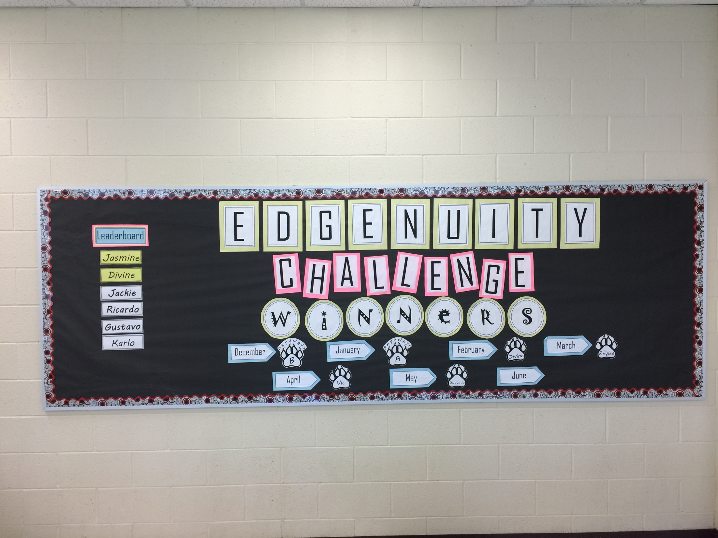

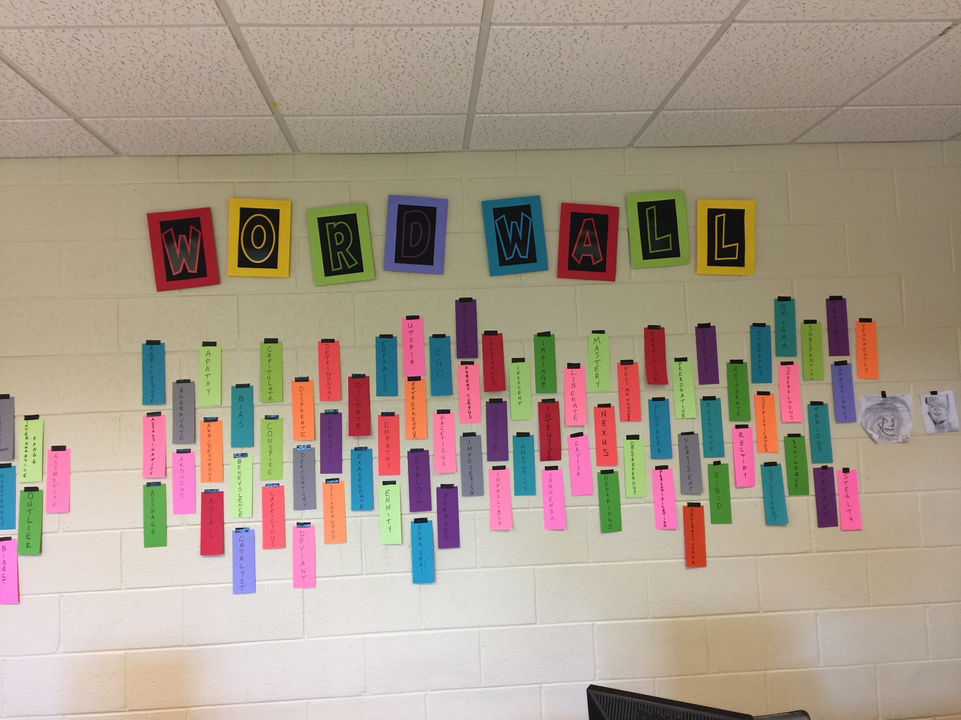

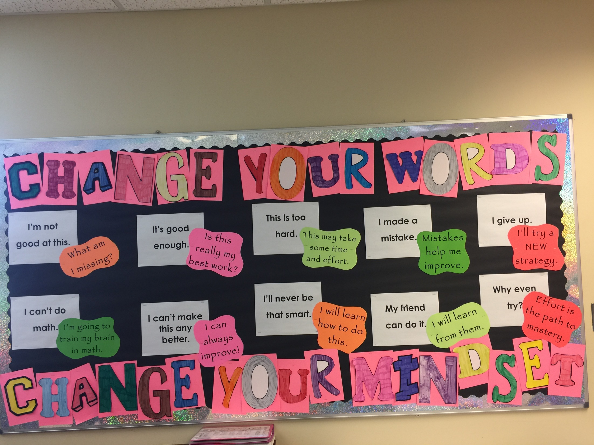

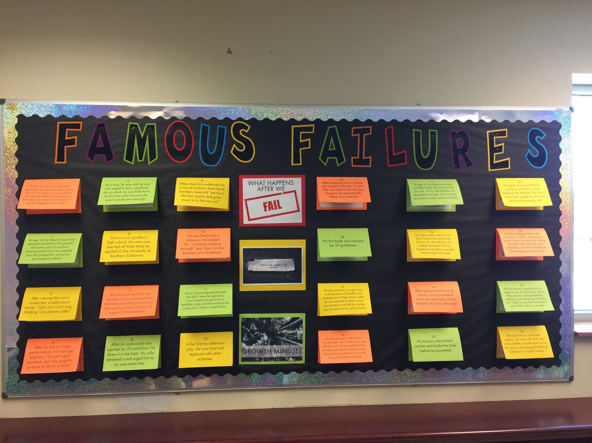

- Magnet Course Proposals SY 2019 – Mrs. Heather Kincaid and Dr. David Ballard
- Description of the Digital Literacy courses for third, fourth and fifth grades
- Description of the Humanities courses for fifth, sixth, seventh and eighth grades
- Selection of two (2) books requested by the sixth grade humanities teachers
  - The Hawk That Dare Not Hunt by Day – Scott O’Dell (75 books approximately $562.50)
  - Hakon of Rogen’s Saga – Erik Christian Haugaard (75 books approximately $851,25)
- Note: some additional tech costs will be evaluated and discussed at a later date

- AAMOU – Reading/STEM/History – Mrs. Heather Kincaid
  - 2018 – 2019 forty (40) student commitment
  - Total budget for program is $22,900
  - $15,500 for East Aurora District 131 program participation
- Priority School Grant Update – Dr. Margo Schmitt
  - FY18 Priority School Grant notified of $3,427.00 additional funds
  - Funds will be given to Oak Park Elementary for differentiation math materials
- ESEA Additional School Support and Preliminary Designations SY 2019 – Mrs. Heather Kincaid
  - ESEA information is being discussed
  - Future communication and information will be brought forward when the final designations are released
- Write To Learn – Dr. Lori Campbell
  - Research-based online literacy tool
  - Automated essay scoring and reporting
  - Diagnostic tool identifies strengths and areas of improvement
  - Incorporates reading and writing development
  - Tracks student progress and differentiation
  - Provides essay prompts, reading passages and questions for students to construct a response
  - Allows students to submit writing drafts six (6) times
  - Instant feedback to students and teachers
- Next Steps
  - Purchase schoolwide subscription of Write To Learn online resources at FRMA
  - Provide professional development
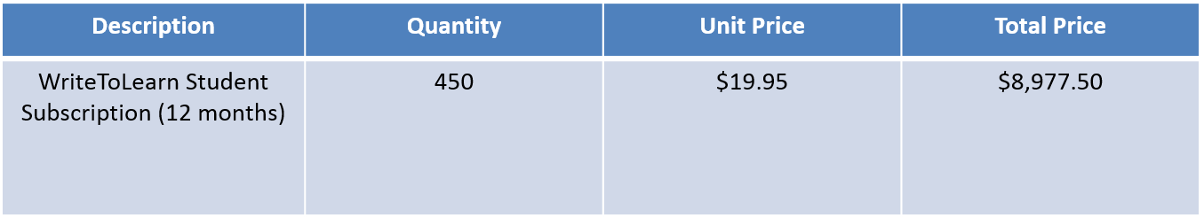

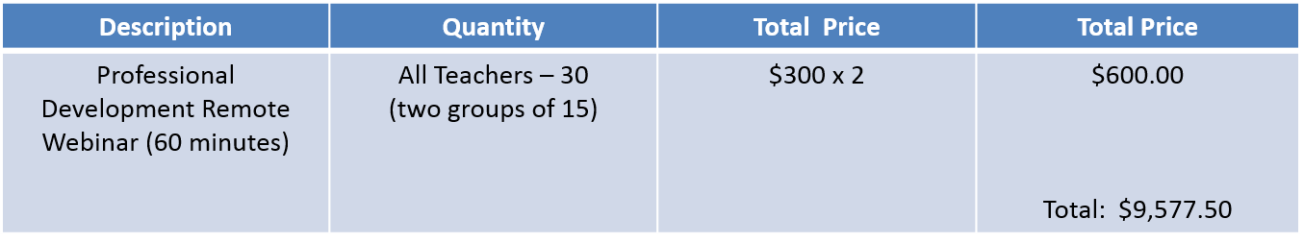

- 2018 – 2019 Curriculum Committee Meeting Dates – Mrs. Heather Kincaid
- Public Comments – Mrs. Sue-Z Bruno – Peace Jam
- Adjournment – 6:53 p.m.

